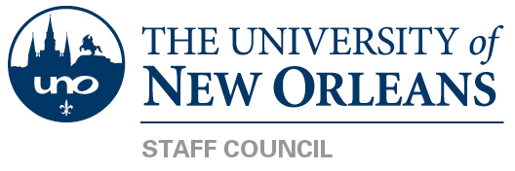

June 18, 2015
Library 407, 10:00AM

The June 18, 2015 Meeting has been cancelled.

***********Note: Next Meeting date is July 23, 2015**********

Staff Council is dedicated to providing the best possible representation for the staff of the university. Our goal is to identify ways to support and enhance the lives of our valued
fellow staff. Staff Council welcomes input from the entire university community in
order to make the University of New Orleans the best place in the City of New Orleans
and the state of Louisiana to work and prosper.

