OFFICE OF RESEARCH

SPIN
User Guide

Contents
Introduction 1
Profile Creation 2
Database Search 3
Basic Search 4
Keyword Search 4
Advanced Search 7
Other Search Options 8
Preferences/Filters 8
Filters 8
Preferences 13
Export Data Options (data field list) 14
Search Results 17
Exporting the Search Result List 19
Opportunity Details 20
Saved Searches 24
Saving a Search 24
View Saved/Shared Searches 24
Bookmarks 27
Bookmark an Opportunity 27
View Bookmarked Opportunities 28
Search Help 31
Basic Search Help 31
Training Videos 32

Introduction
InfoEd Global offers a database called SPIN (Sponsored Programs and Information Network) that contains over 40,000 opportunities from more than 10,000 sponsors. Through the Louisiana Board of Regents, UNO faculty, staff and students have access to this database. SPIN can be accessed from any computer operating through the UNO server or a profile can be created to allow access from any computer.
SPIN Sponsors include federal agencies, private companies, and not-for-profit entities. Users can search for opportunities by keywords and can use filters of applicant location or type, project type or location, citizenship status, and sponsor type to refine the search results. Two capabilities in SPIN, saving a search and bookmarking a funding opportunity, can only be used if the user is logged into SPIN (i.e. a profile has been created and the user has logged in).

Profile Creation
Creating a profile allows the user to save searches, establish funding alerts, and bookmark funding opportunities. A profile also allows the user to utilize SPIN from any computer. To create a profile, click “Sign In” from the main screen.
Click “Need to create a new profile?”.
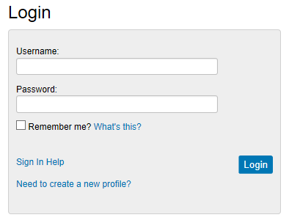
Use the drop-down arrow to select UNO from the list and enter the requested information; check the “I’m not a robot” box and follow the instructions provided.
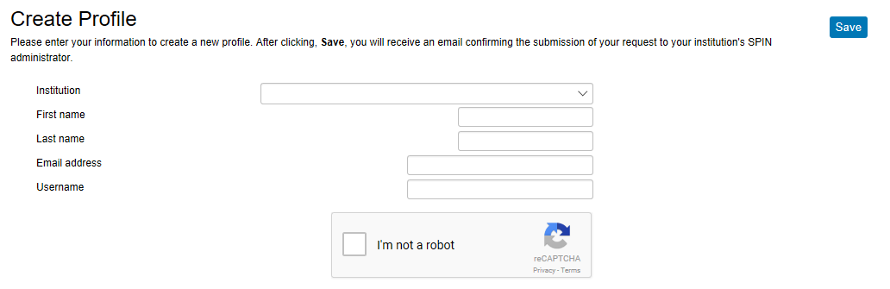
Then click “Save”.
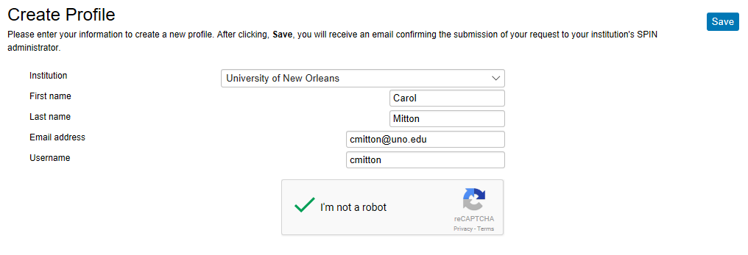
A UNO administrator will have to approve the request for a profile. Once that approval is granted, the user will receive an email.

Database Search
SPIN provides several options to search the database for funding opportunities. Search parameters can be saved and email alerts set for users that have an account in SPIN and are logged in when the search is performed. Saving searches is discussed later in this document.

Basic Search
When SPIN is opened, the default is a basic search. To perform a basic search, enter a keyword in the field provided and click “Locate Funding” from the main screen.
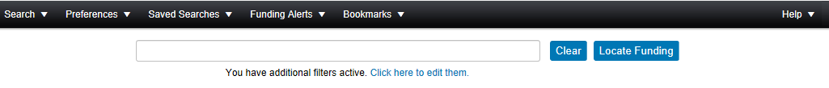
The search results can be refined by utilizing either category filters or search options, which are discussed later in this document. The search result list is discussed later as well.

Keyword Search
SPIN also has a keyword search option which allows the user to select keywords from a provided list. Select Keyword Search from Search drop-down menu.
A “Select Keywords” link will be provided above the keyword field; click the link.
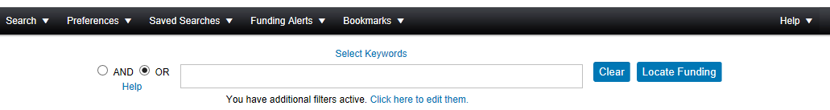
A pop-up window will appear. When the user starts to enter a value in the field provide, the system will provide a list of possible values based on the data being entered. Either select a value from the offered list or continue to type. When done, click “Find in list”.
Then click the box next to the keyword selected, if it is correct.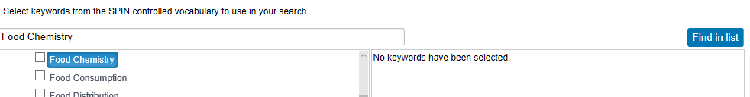
The keyword is then added to the box on the right.
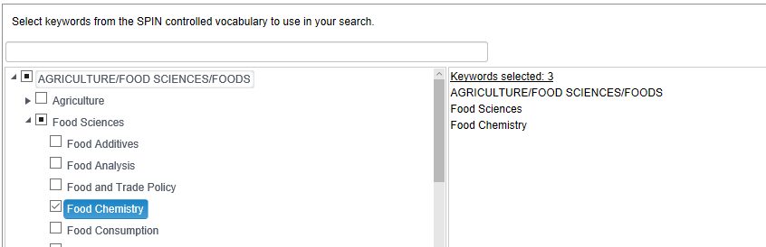
Another option is to use the list provide in SPIN by broad categories. Expand the list of keywords by click the arrow to the left of the broad category.
Expand the subcategories in the same manner to find the appropriate keyword. The box by the category or subcategory can also be checked to select all keywords under that option; the search may result in a long list of opportunities so this may not be useful. Check only the appropriate boxes to make sure the results are useful.
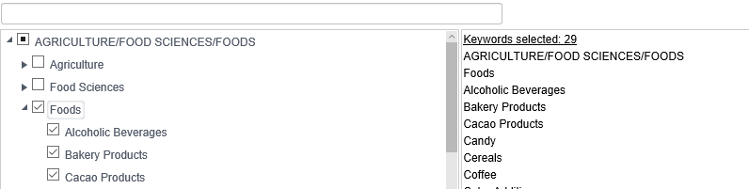
Add as many keywords as desired. When done, click Save “Selections and Continue”.
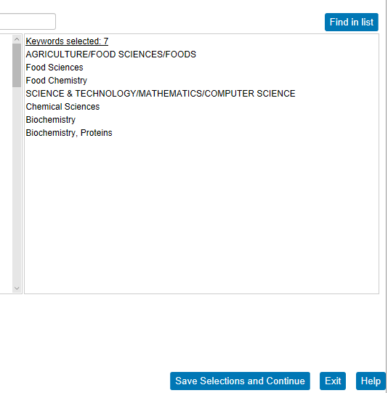
Select the radio button for either AND or OR; the default value is OR. When done, click “Locate Funding”.
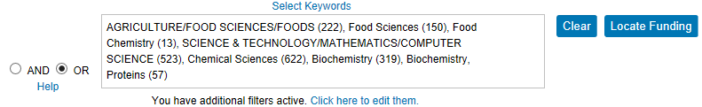

Advanced Search
An advanced search allows the user to add expressions and groups of keywords to refine the search results. To access the advanced search option, click Advanced Search from the Search drop-down menu.
The advanced search allows the user to enter a value for the various fields of the funding opportunity, such as CFDA number, sponsor, deadlines, and many others. The default is Full program; use the drop down arrow to select a different value.
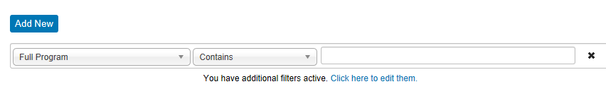
When a different value is selected for the first column, the middle column will change to match the value that will be entered in the final column. The user can select a different option for the middle column by using the drop down arrow. Enter a value in the field provided.
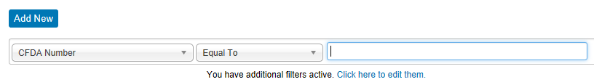
If additional search criteria are desired, click “Add New”.
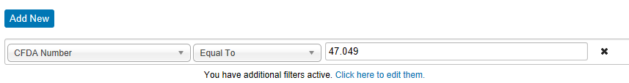
Add as many values as necessary. If a value is added by mistake, click the x on the row. When done click, “Locate Funding”.
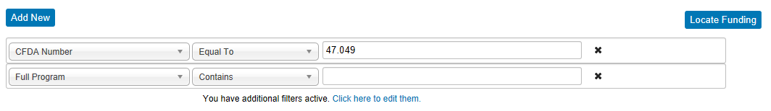

Other Search Options
SPIN allows the user to perform a quick search based on provided options listed on the bottom half of the Search menu. Each option will either provide a list of funding opportunities or links to other locations.

Preferences/Filters
Preferences or filters allow the search to be more specific to fit the user and the type of funding the user would like to locate.

Filters
The preference/filter options include applicant location and type, project type and location, citizenship, and sponsor type. Users can also select options related to what and where to search. There are two options to select preferences/filters. The first is from the Preferences menu option in the top menu bar. To open the filter pop-up window, click any of the first six options.
The following pop-up window will open with tabs for each of the six filter options. Each tab will have different options on the left, but the layout is the same.
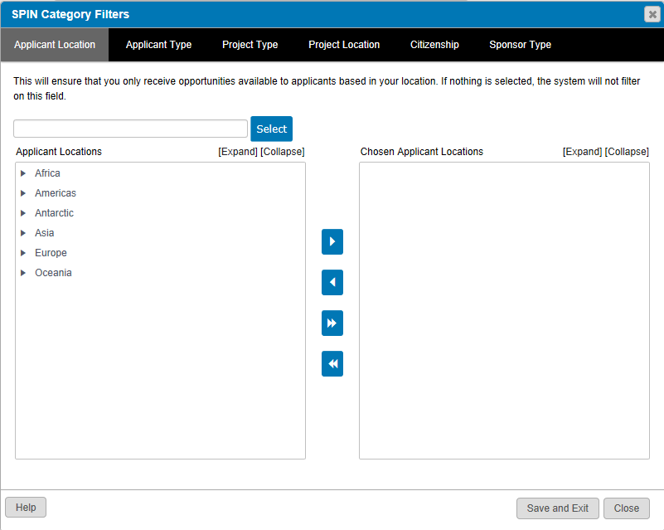
On each of the filter screens, there are two options to select a filter option. The explanations/instructions starting below apply to all of the selection screens even though only the project location screen is used in the example.
The first filter selection option is to enter a value in the field provided (near the top of the pop-up screen. As a value is entered, the system will provide suggestions. A value can be selected from the options given or the user can continue typing. When done, click “Select”.
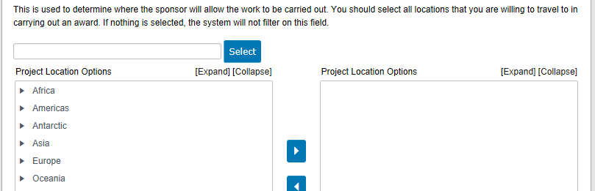
When “Select” is clicked, the entered value is moved to the “Options” box on the right side of the screen.
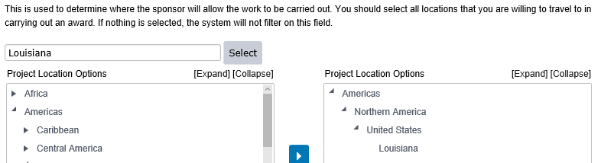
The second option is to select a value is to expand the options given on the left box of the pop-up box. To expand the list, click the arrow to the left of the value.
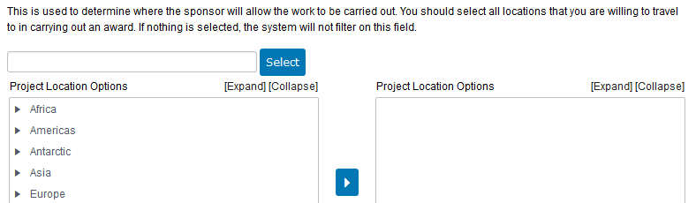
Additional values will be available for selection. Keep expanding the list as necessary. Once the desired value is selected (clicking the value), click the top arrow in between the two boxes.
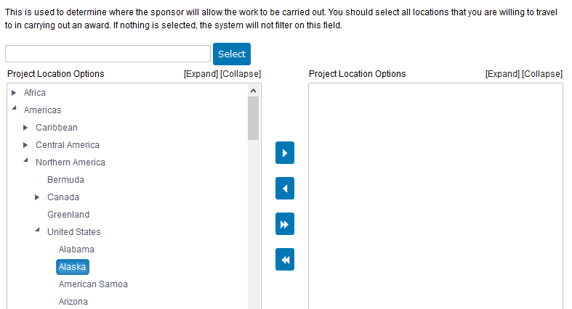
The selected value is moved to the right hand side. Multiple values can be selected. Once done, click “Save and Exit” on the bottom of the screen. The search screen will return and the search can be completed as described earlier in this document. NOTE: Values can be chosen from any or all of the filter options. Make all of the selections before clicking “Save and Exit”.
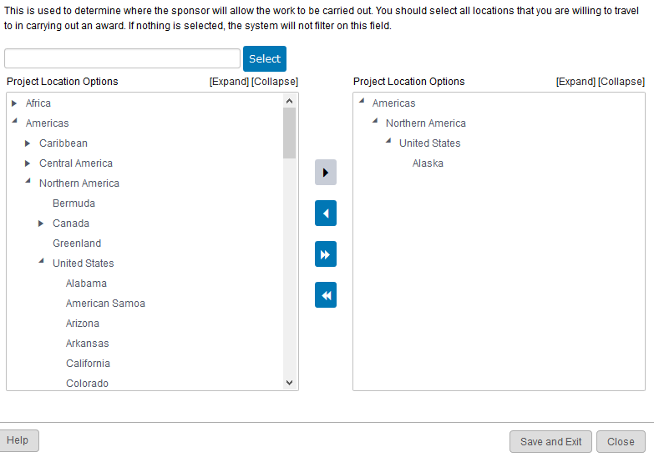
To remove a value on the chosen list, click the value and then click the second arrow.
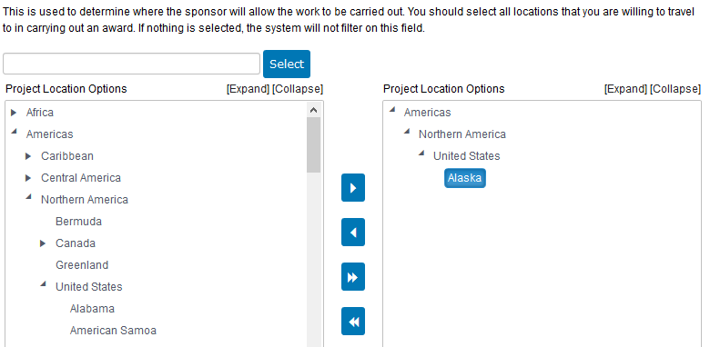
The double arrows on the bottom move all of the values on the left side to the right, chosen side or removes all values on the chosen list for that filter option.

Preferences
In addition to the filter options just discussed, selections can also be made for the six preferences located in the Preference menu option.
If any of the preferences is selected, a pop-up box will appear that lists all of the preferences. Selections can be made to any or all of the options. The options for the drop-down menus in the pop-up box are include, exclude, and only. The currency list drop-down menu has a long list of possible values; any value can be chosen. Once done, click “Save and Exit”.
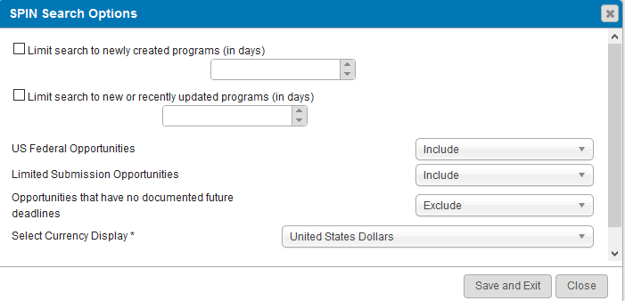
The search screen will return and the search can be completed as described earlier in this document.

Export Data Options (data field list)
Export data option allows the user to select the fields to include in a document exported from the search result list or the bookmarked list. The selections also determine the fields included on the quick view of a funding opportunity directly on the search result screen. SPIN has default values that can be added to or removed. To make changes to the data fields list, select Export Data Options from the Preferences menu.
A pop-up box will appear. To add a field name, click the name on the left side and then click the top arrow in-between the two boxes.
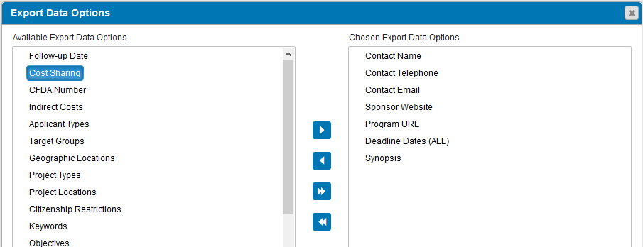
The value will be added to the chosen list on the right. Add as many values as desired. To remove a value from the list (even a default value), highlight the name on the right side and click the second arrow. Make as many additions and/or deletions as necessary. Once done, click “Save and Exit” on the bottom to save the changes.
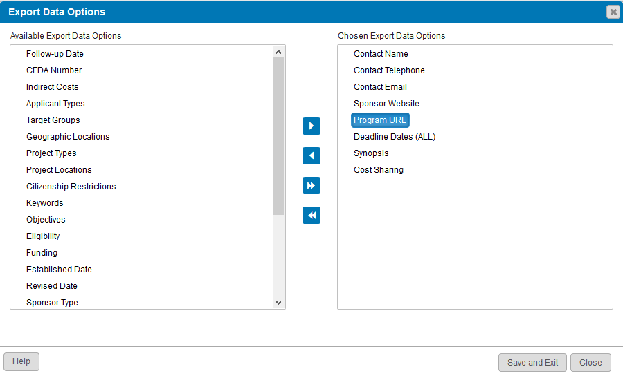
The double arrows on the bottom move all of the values on the left side to the right, chosen side or removes all values on the chosen list.
The second way to modify preferences/filters from the search screen is to click the link under the keyword field on the main screen.
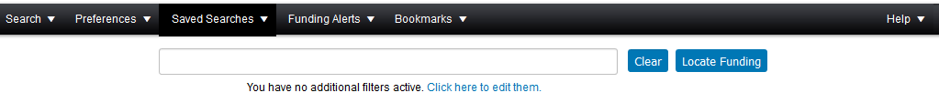
The following screen will appear. If values were selected for any of the filters, the values will appear on the screen. Changes can be made by clicking the “Edit” button in any of the boxes or the filter links. All filters and option choices can be reset to the default values by clicking the “Reset Filters” link at the top of the screen.
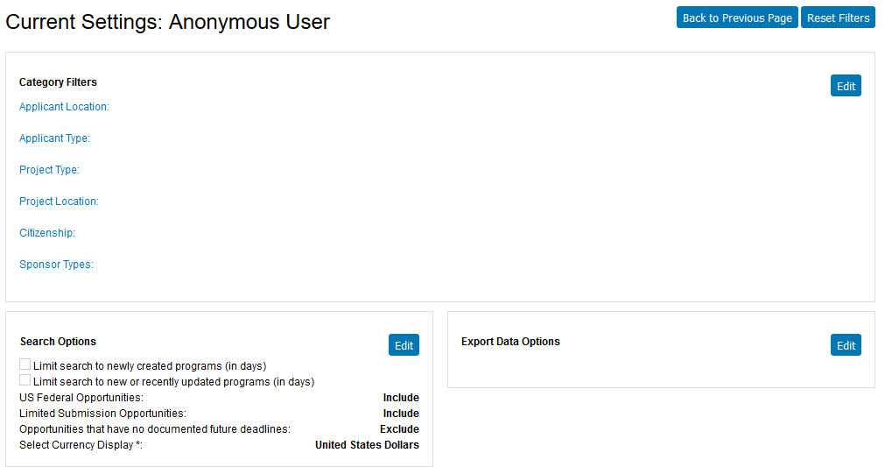
When “Edit” is clicked, the user will be taken to the selection screen/pop-up for the respective filter or option. The screens will be the same as previously discussed.

Search Results
After performing a search, SPIN will return with a list of opportunities with basic information about the opportunities. The list can be sorted by clicking any of the column headings. Also, the opportunities can be grouped by any of the columns. To group the opportunities, click and drag a column heading to the field above the list. NOTE: The following is a search done by a user not logged into SPIN.
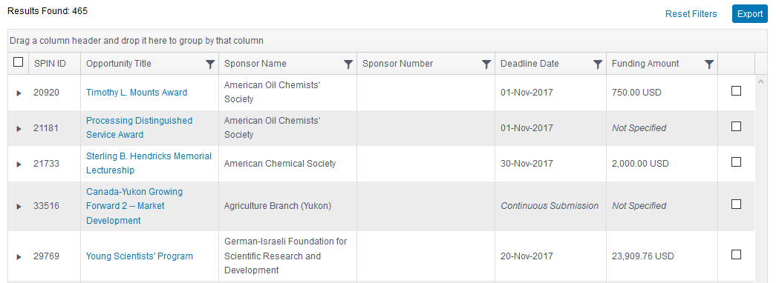
The following is the same list but grouped by sponsor name; the list is also alphabetized by sponsor.
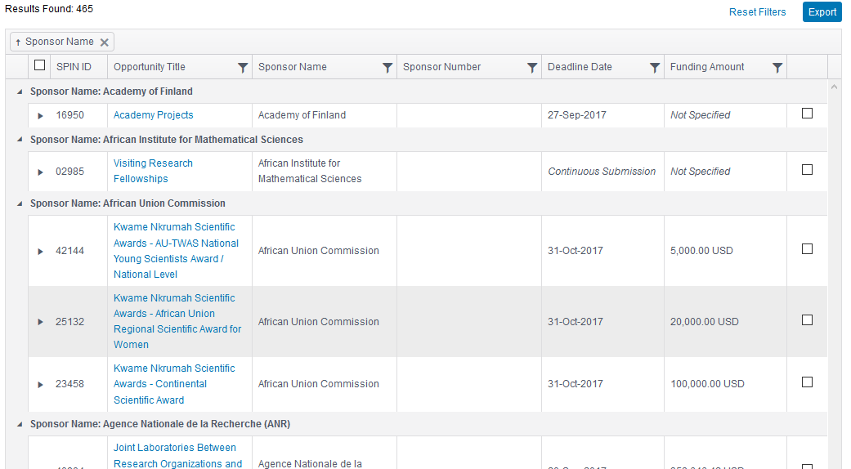
If filters were added or changes made to any of the search options, the additions and/or changes can be removed by clicking the Reset Filters link on the search result screen.
Then click “Clear Filters”.
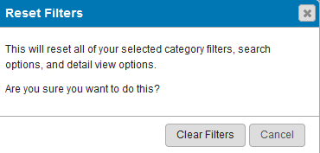

Exporting the Search Result List
The funding opportunity list can be exported to either MS Word or MS Excel. The export option is in the upper right-hand corner of the search result screen.
Note, only the opportunities on the current page will be exported. The default is to have 25 opportunities to a page. To increase the number of opportunities to export, use the drop down menu next to “25” on the bottom menu. The choices are 25, 50, 100 and All.
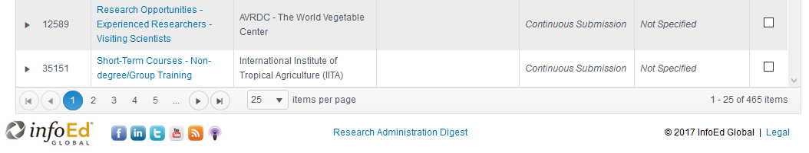

Opportunity Details
There are two options to get additional information on the funding opportunity. Additional details can either be opened within the search result list or opened to another window. To get additional information without leaving the result list, click the arrow button next to the opportunity.
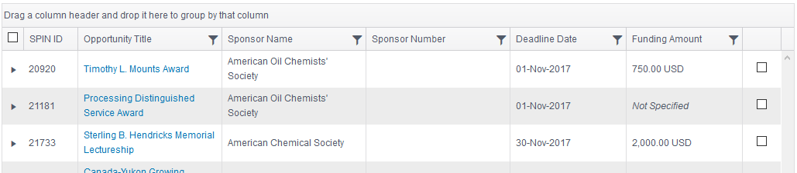
Additional fields are opened on the screen. The fields can be minimized by clicking the arrow box again. The details to be shown can be changed under Preferences (Export Data Options) on the main menu (discussed previously in this document).
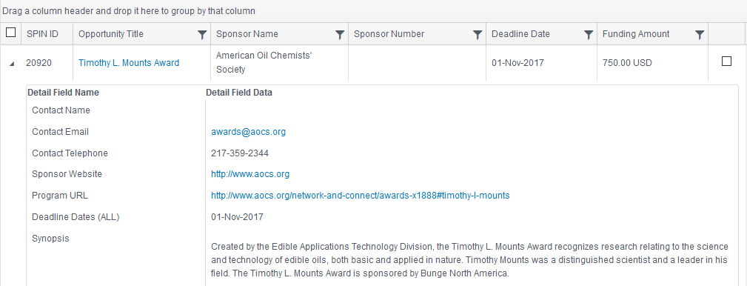
Another option to get more information on the opportunity is to click the opportunity title.
Details on the funding opportunity will open in a new window. The funding detail page will default to the opportunity description tab but there are tabs for eligibility requirements, funding guidelines, and sponsor information; screen shots for each of the tabs start below.
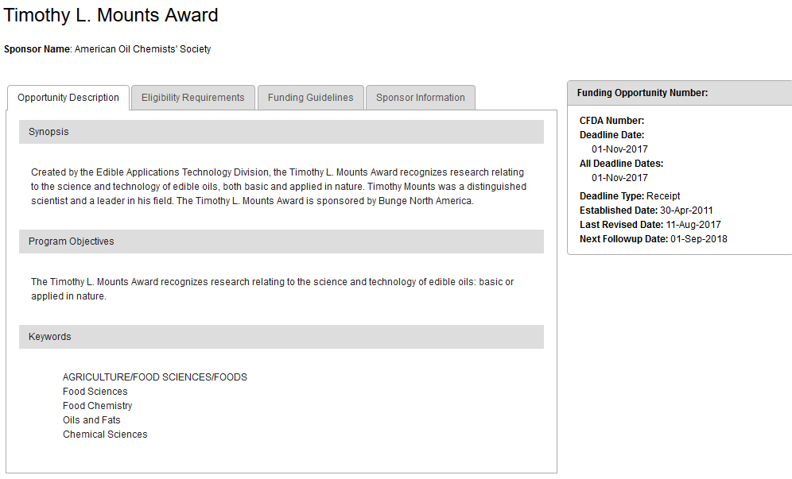
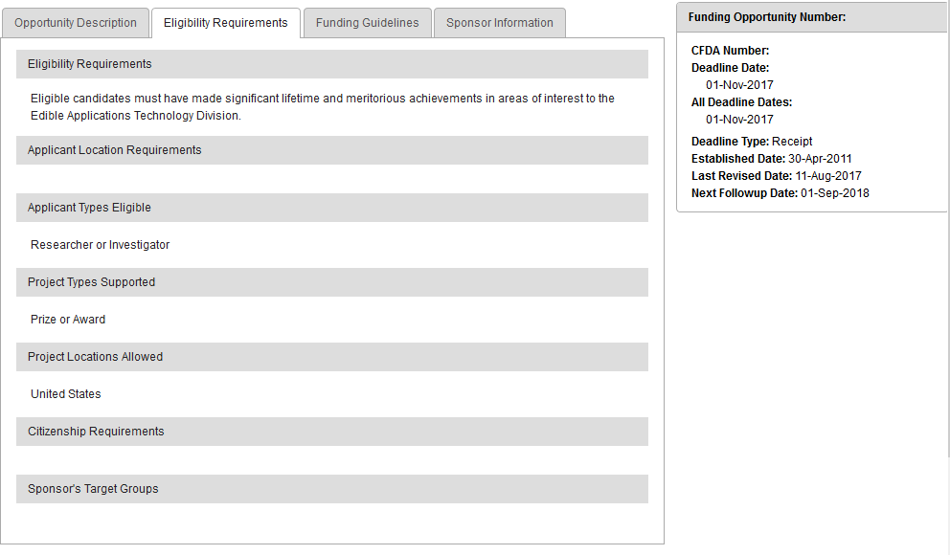
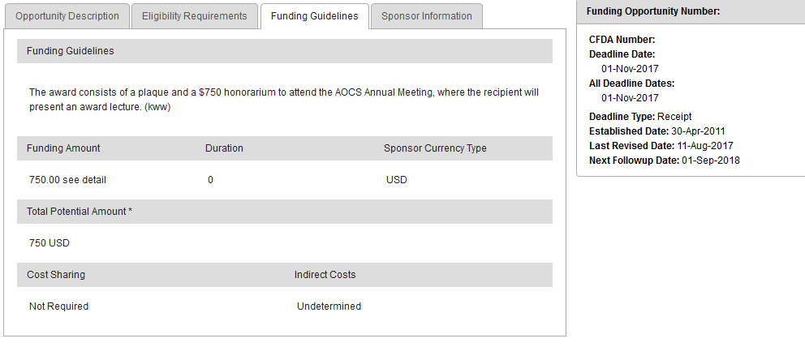
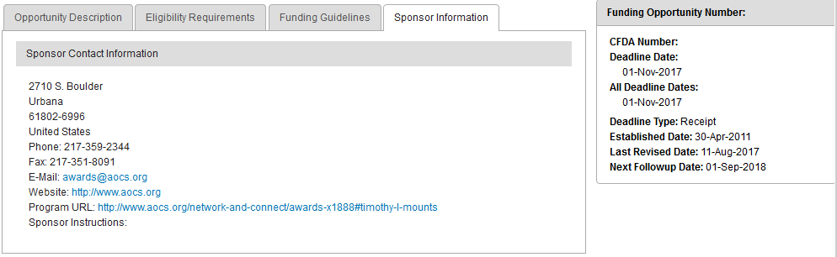
On the top of the funding detail page is an option to email the complete opportunity to someone. The information can be sent as either HTML or text. Use the drop down menu to make the selection.
Once the selection is made, a pop-up window will open and the “from” and “to” email addresses need to be entered. The subject can also be changed if desired. Once done, click “Send”.
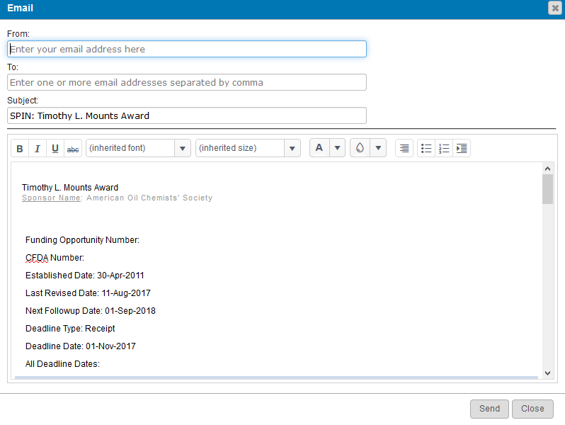
Within the Options menu on the opportunity detail page is the capability to search for similar opportunities.
If selected, the system will provide another list of funding opportunities to browse through.
Once done with the opportunity (or the list of similar opportunities), close the window to return to the initial list of opportunities.

Saved Searches
Searches can be saved by a user who has logged into SPIN. The sign in link is on the top right-hand corner of the SPIN screen.

Saving a Search
After logging into SPIN and running a search, a “Save” button will be available next to the “Locate Funding” button. To save a search (once all keywords, filters, and options are selected), click “Save”.
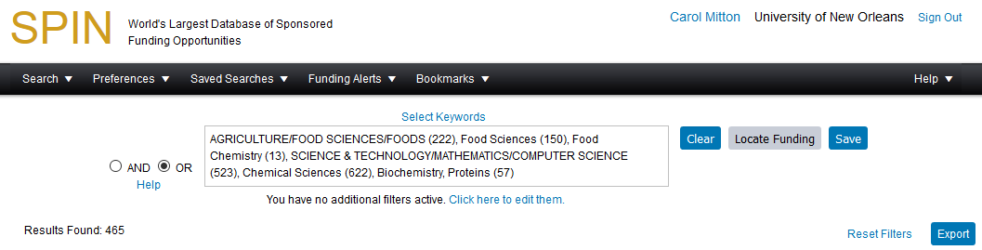
Add a name to the search and select whether email updates are desired (either HTML or plain text) and email frequency (daily or weekly). Then click “Save Changes”.
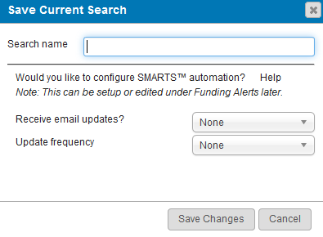

View Saved/Shared Searches
Search parameters can be saved by a user who is signed into SPIN (see previous discussion). Also the UNO administrator can save and share searches which are available to users without logging into SPIN; the user must be using a computer on the UNO network though.
To view shared searches, select Public Searches from the Shared Searches menu (the menu option below is for a user not logged into SPIN).
If there are any available (currently UNO does not have any), they would be listed on the screen below. Running a saved search is discussed below.
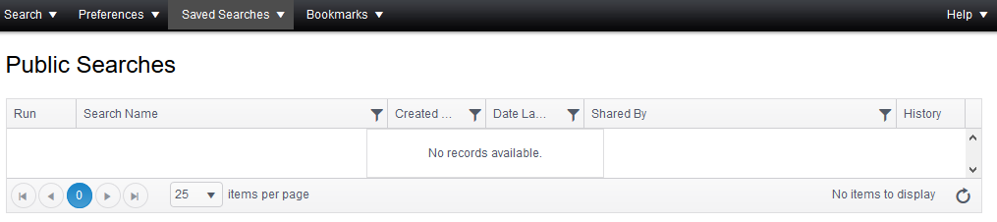
Searches saved by the user are only available if the user is logged into SPIN. If the user has saved searches, they will be listed on the Saved Searches drop-down menu. There are two options to run a Saved Search. The first is to click the appropriate name in the list provided on the Saved Searches drop-down menu.
Then click “Load Search”.
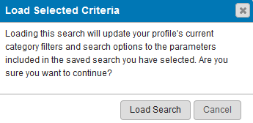
Results from the search will be provided on the screen. See the previous discussion in this document on how to utilize the result list.
The second option to run a saved search is through the Manage Saved Searches option of the Saved Searches menu.
The system will provide the list of searches which will include the creation date and the date it was last used. To run a saved search, click the green arrow in the Run column for the appropriate search.
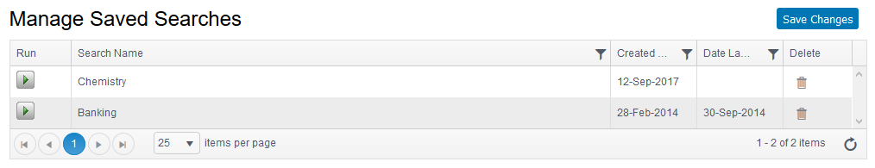
Then click “Load Search”.
Results from the search will be provided on the screen. See the previous discussion in this document on how to utilize the result list.
If the user would like to remove a saved search, click the icon in the Delete column for the appropriate search. The user will be asked to confirm the deletion.

Bookmarks
SPIN gives the user the option to mark an opportunity for future reference. Alerts can also be setup to receive an email when an opportunity within a bookmark group has been changed (new submission deadline, changes to requirements, etc.). The individualized bookmark feature is only available to users who have signed into SPIN. The UNO administrator can share bookmarks which will be available without logging in.

Bookmark an Opportunity
If the user has logged into SPIN (sign in link is in the upper right-hand corner), there are two options to bookmark an opportunity. On the search result screen, click the plus button for the particular opportunity.
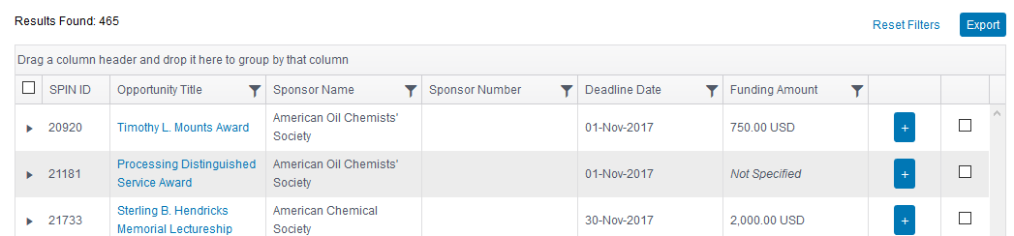
Or click “Bookmark Program” on the opportunity detail page (appears after clicking the opportunity title from a search result list).
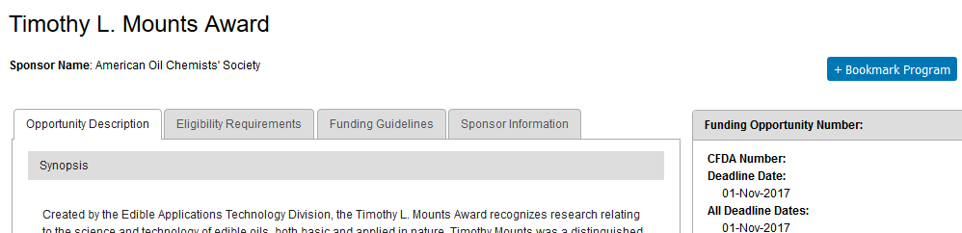
After selecting either option to bookmark an opportunity, a pop-up will appear asking the user to create a group or to select existing group in which to place the funding opportunity. Enter a name or select a group, then click “Save Changes”.
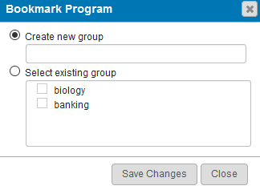

View Bookmarked Opportunities
If the user is not logged into SPIN, only Public Bookmarks are available under the Bookmarks menu option. To view shared opportunities, select Public Bookmarks.
If there are any shared opportunities (currently UNO does not have any), they will be listed within groups on the screen below.
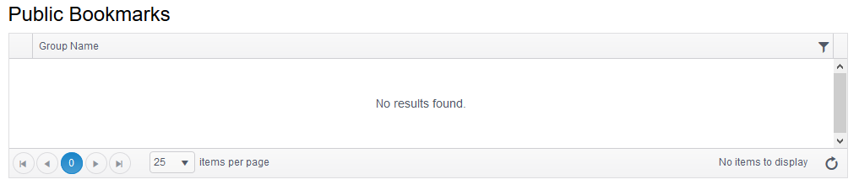
Opportunities bookmarked by a user are only available if the user is logged into SPIN. To view bookmarked opportunities, select Manage Bookmarks under Bookmarks.
The bookmarked opportunities are listed by group names. To see the individual opportunities, click the arrow next to the group name.
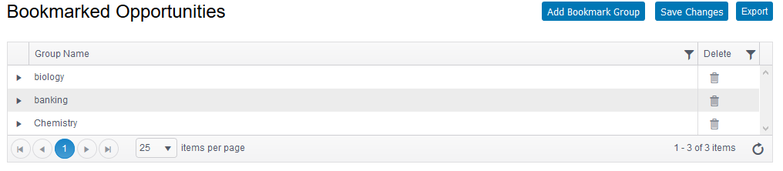
To go to the funding opportunity detail page, click the opportunity title. The opportunity detail page is displayed and discussed earlier in this document.
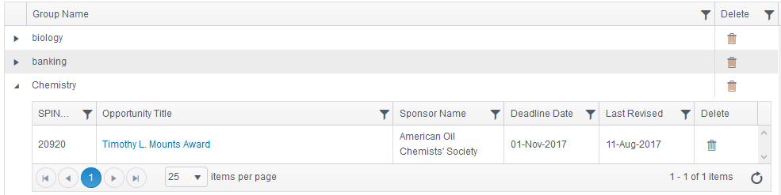
An individual opportunity or the entire group of bookmarks can be removed by clicking the icon in the delete column (this option is only available for opportunities that the user bookmarked and not the shared opportunities).
The user can also create a bookmark group from this page. Click “Add Bookmark Group”.
The following pop-up will appear requesting the group name. Add the name and click “Save Changes”.
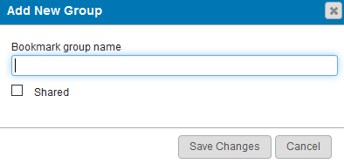
The list of bookmarked opportunities can be exported to Excel or Word; click “Export”.
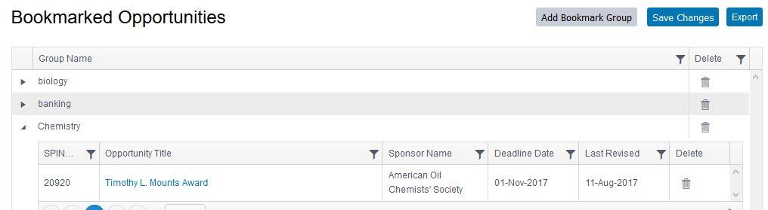

Search Help
SPIN has two tools available for assistance – basic search hints and training videos. Both tools are available through the help menu on the main page. Users do not have to be logged into SPIN to use the help features.

Basic Search Help
When the Basic Search Help option is chosen, a pop-up box will appear that explains the SPIN search process and provides pointers on how to enter keywords for a search. There are three search help options: Text Search, Keyword Search, and Advanced Search. Click the appropriate option.

Training Videos
SPIN offers numerous videos to assist users in searching for funding opportunities. To view the video, click the appropriate title; the video will open on a separate page.
