Email Etiquette: Do’s and Don’ts
The most important tip of sending emails is to be patient. Especially during COVA-19 online class transitioning, professors and staff are overwhelmed with planning and transiting, just like students. Follow-up emails are ok, so long as you allow 24-48 hours for a response before following up. This may mean you need to plan projects/ assignments to allow time for questions.

General Don’ts:
Definitely Do: 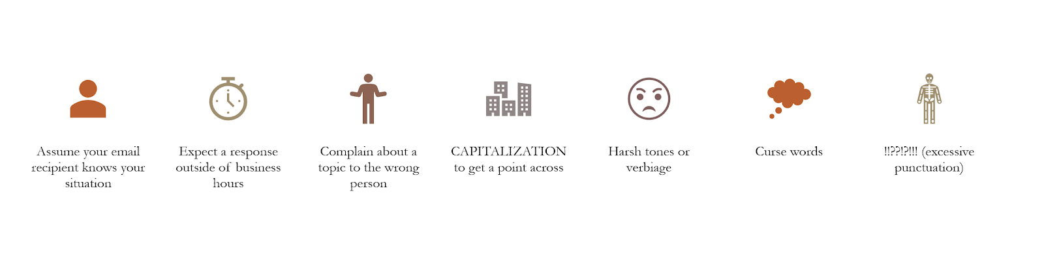
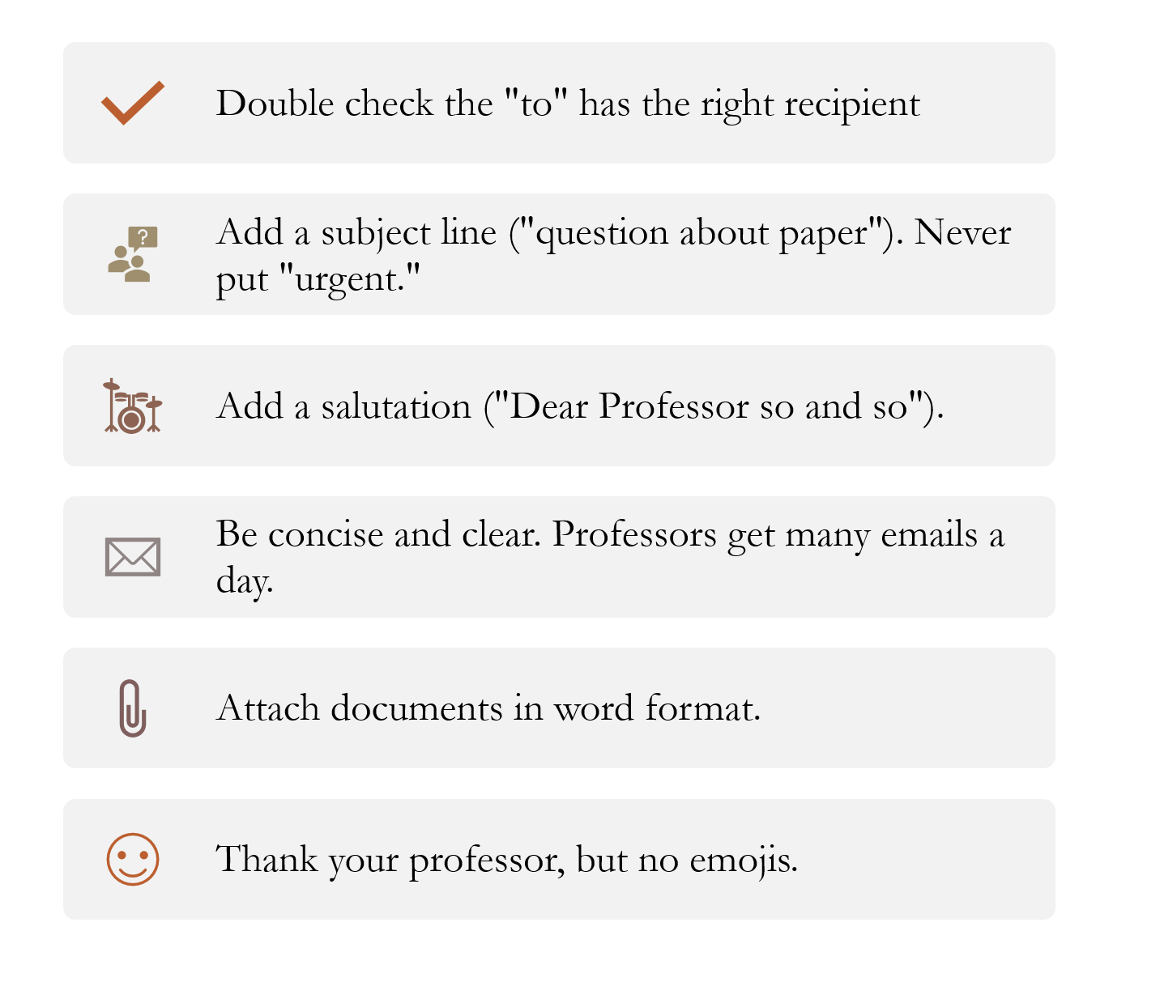
Try to always use your @uno.edu email, and include your relevant class/ section information
Email Etiquette: Let’s Learn By Example!

Example Email One:

Hello Dr. O’Dell,

I have some concerns regarding how to manage my classes entirely online. Can I schedule a phone or video call to talk about this matter?

Best,
Student X

So, this email is off to a great start, but the first sentence is a tad vague. What about moving entirely to online classes is concerning?
Of course, the entire notion can be stressful, however pinpointing a specific worry is always better. Perhaps this student is concerned about managing their time with online classes, learning outside of a lecture-based environment, or worried about an reliable internet connection.
State these concerns in the email! Being as specific as possible will only help the email recipient help you easier and faster.

Example Email Two:

Hello Professor Banks,

I am in your Literature of Exile class, section 1. I have two issues regarding the assignments this week. First, I received an error from turn-it-in, stating my weekly reflection could not be uploaded. What should my next steps be for this assignment? I attached it to this email just in case.

Secondly, I am having trouble finding our next assignment, “Listing scenes and their functions for plot” on Moodle. I looked under the “assignments” tab, and did not see it listed. Is it under a different name?

Best,
Student X (ID# 34561)

This email has all the aspects of successful emails. The student clearly states the class they’re in, section, and ID number. The two questions are separated by paragraphs, so each isn’t easily missed. For the turn-it-in problem, the student problem solves on their own by attaching it to the email, while still looking to the professor for guidance.
For the assignment issue, the student states what problem solving they’ve already done. This will avoid the professor getting unnecessary emails from students who haven’t exhausted all their go-to problem solving solutions. Listing what the student has already tried also prevents the professor from responding with solutions the student has already attempted.

Fatal Mistakes

- This is not Facebook or any social media platform. Don't write the professor in the way you'd write on your friend's wall (I don’t remember the last time that I did an assignment in this class girl, lol!).​
- This is not texting. So, pls don’t write ya prof lik yr txtn ya boo, lmao. ​
- This is not CollegeHumor. Resist the temptation to talk about the "bad ass" paper you need help with, your "loser" instructor who didn't teach you what you needed to know.​
- This is not RateMyProfessor.com. The professor does not want your comments about his or her performance in the class. Save those for the end-of-semester evaluations.​
- Spelling mistakes make you look like a doofus. So always use the spll chek, and proofread you email, two.​ And, don’t use shorthand or abbreviations. (See how bad that looks?!)
- Sign-offs and signatures count. Always end by thanking the professor for his or her time, and closing with “Sincerely”, "Best wishes", or "Regards." And always sign with your (entire) real name, not some wacky nickname like Bro Montana.​

