ADVISOR TEXT

UNO students now have access to CircleIn an app that connects you to classmates and rewards you for studying! Check your email for details. Join now: Click Here

ADVISOR EMAIL

CircleIn App for Building Community in Your Classes
Log-In Instructions

(Use UNO student email as username and then password) and here is link

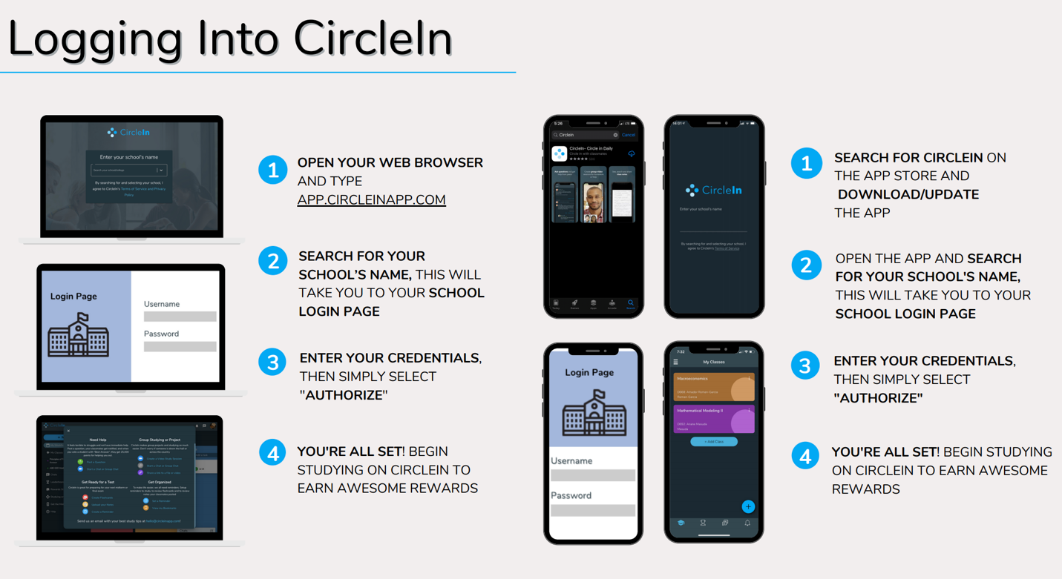

Or watch video: https://vimeo.com/showcase/7968089/video/496757243

Once you’ve logged in, you’ll be instantly connected with all of your classmates and will have access to multiple studying features, all in one place, that will help you stay productive and succeed!

Make sure to let your classmates know about this new and exciting opportunity!

Want to learn more? Check out the attached “Student Welcome Guide” or click here to visit the CircleIn Student Website.

Welcome back to classes and wishing all of you a successful semester!

