October 6, 2022

Dr. Jim Henderson
President
The University of Louisiana System
1201 North Third Street
Baton Rouge, LA 70802

Dear Dr. Henderson,
On behalf of the University of New Orleans, I would like to request that the following items be placed on the agenda for the October 27, 2022 University of Louisiana System Board Meeting:
Request for approval to hire Dr. Darrell P. Kruger as Provost and Senior Vice President for Academic Affairs
Request for approval of certain agreements between the University, the University of New Orleans Research and Technology Foundation, Inc. and LA Energy Partners, LLC

Request for approval of Personnel Action Requests:

Retirements/Resignations/Terminations

- Non-Classified Leave of Absence
- Non-Classified New Positions
- Non-Classified Promotions/Changes
- Non-Classified Replacements
- Additional Compensation
Thank you for your consideration of these items.
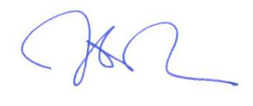
Sincerely,

John W. Nicklow
President

