How to complete a Fire Drill Report in Workday
The purpose of this document is to provide a step by step procedure on how to access the new Fire Drill form that is located on Workday. You can also print out and complete a paper copy of the Fire Drill Evacuation Report, located on our EHSO web page if you prefer. (https://www.uno.edu/media/15301 )
See the red arrow for the location of your response
Open Workday and locate the “search bar”
Step 1 – type “create request” in the search bar

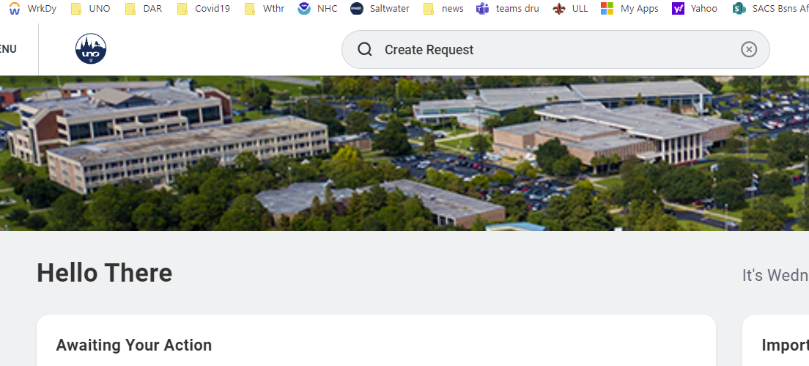

Step 2 – when the drop-down menu appears click on Create Request

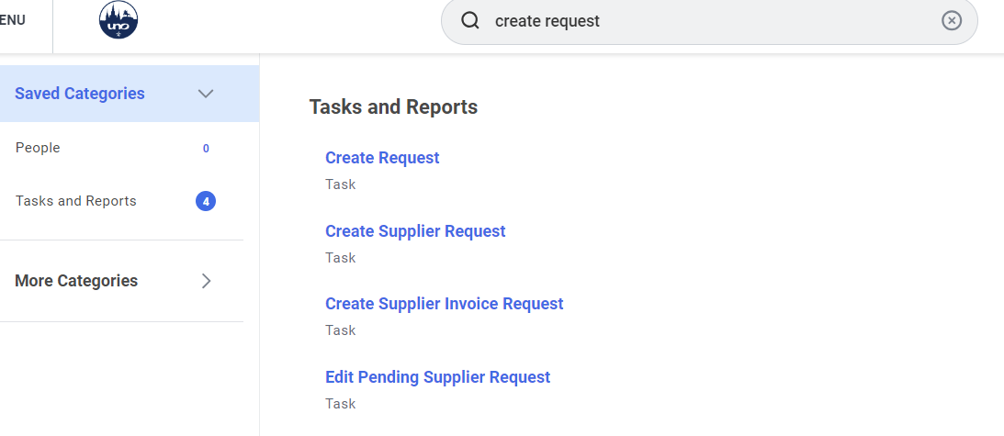

3- when the “Create request box” appears – type “fire drill” and then click “OK”

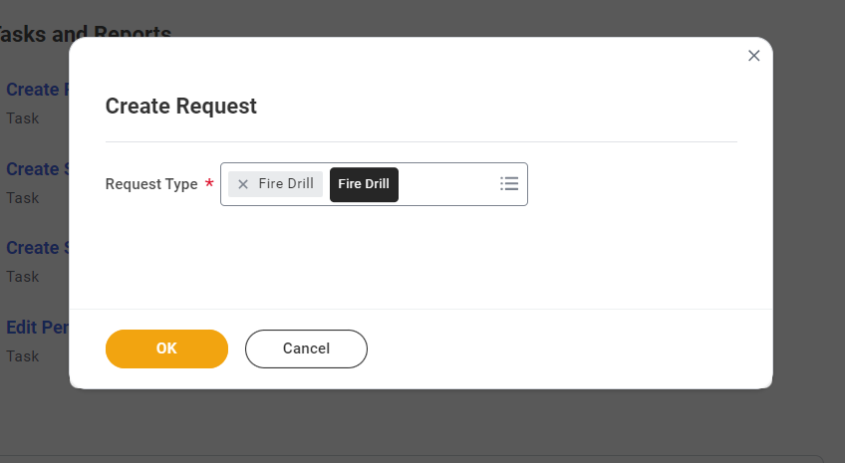

This will bring you to the “Fire Drill Form”. Complete the form and at the end click on the “submit” button.
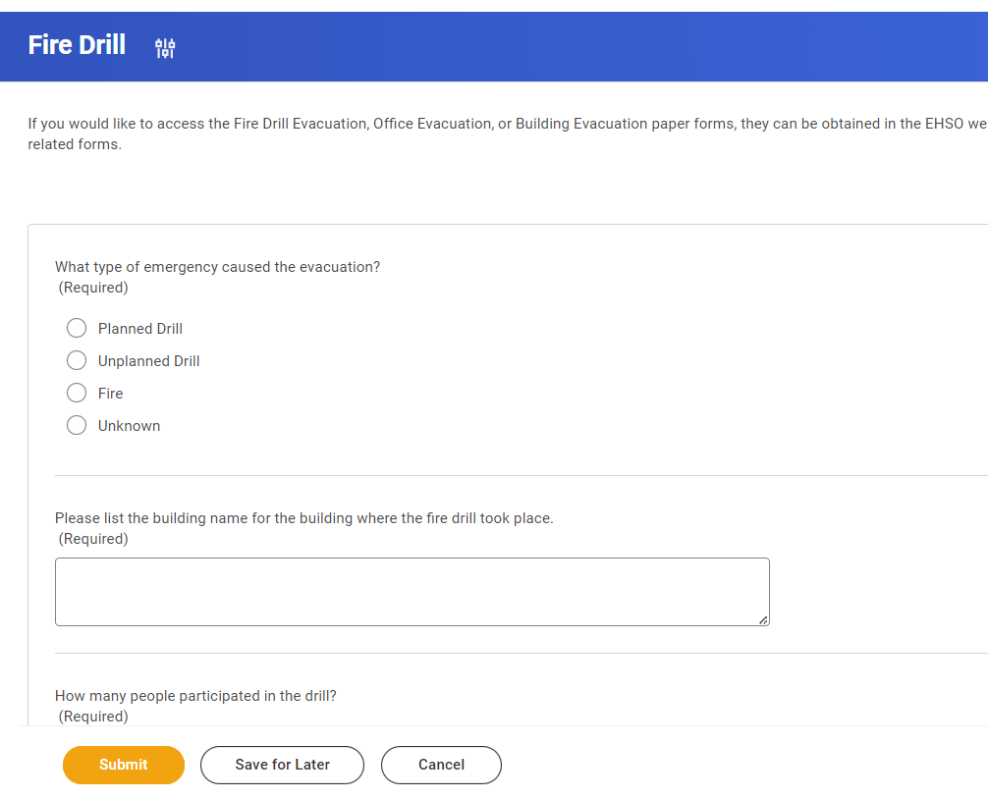
There is a “Comment” box at the end of the form where you can report any areas of concern. Any notes contained in this area will be shared with Facility Services and their contractors for investigation/repairs.

