PeopleSoft 9 Academic Scheduling Training

Useful Terms
Course - Made up of a subject and number for which there can be multiple sections (ie ENGL 1157)
Section - An individual group of meetings of a single course (ie ENGL 1157-001)
Instructor of Record (IOR) - The faculty member assigned to teach and report grades for a section.

Step 1 - Log In
Open Internet Explorer or your web browser of choice. Navigate to WebStar (http://webstar.uno.edu). Click whether you are Faculty or Staff.

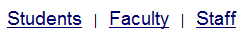

Log in using your UNO username and password.
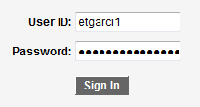
Navigate to Main Menu > University of New Orleans > Student Records > Class Schedule Input/Utilities > Class Schedule Input

Step 2 – Select a Term
You will be presented with a list of present and upcoming terms. Select the term you desire to work with by clicking the link.
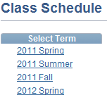

Step 3 – Add Courses
The next screen will display all of the courses sorted by Subject and Catalog Number.
To add a course, click the Add A Class button.

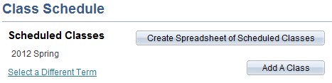

A list of subjects you are authorized to schedule will appear. Click the subject you want to schedule. A list of courses will appear on the right-hand side. Select the desired course from the list.

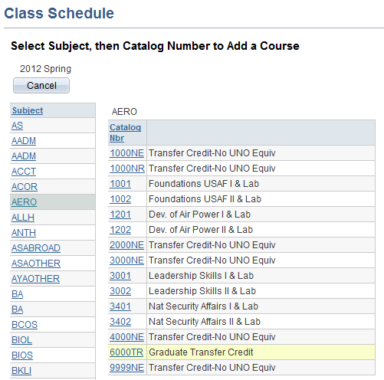

You will be prompted about your selection. Click OK to verify your selection.

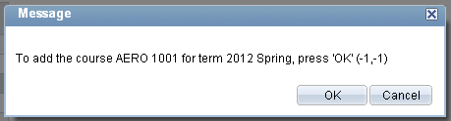

Press OK to proceed or Cancel if you would like add more courses before moving on.

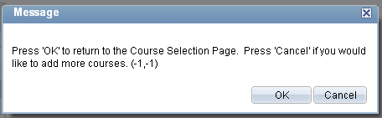

Please note that combined courses are treated as separate entities with identical information (ie MURP 4062 and MURP 4062G). Each entity must be added, and each entity must contain identical sections, departmental consent, enrollment capacities, meeting pattern(s), and instructors of record.

Step 4 – Edit Course Information
After adding courses, you should be returned to the class selection page. Here you will see all the classes you have entered. To edit a course’s information, click the course title you wish to edit.

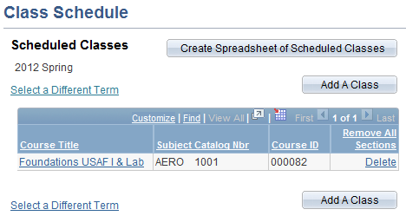

The course will be setup with one section (001) with a blank meeting pattern, no Instructor of Record, no departmental consent, and enrollment capacity of 0 (zero).
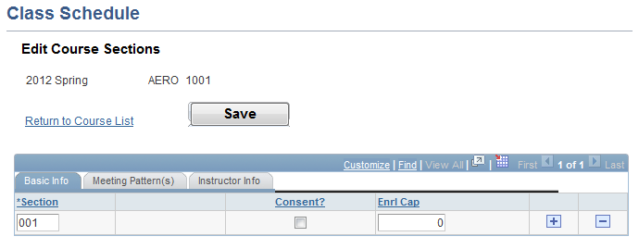
In any tab of the Edit Course Sections page, you will be able to add or delete a section by simply clicking the + (plus) or - (minus) buttons, respectively, on the right. You may also change the section number on the left.

Under the Basic Info tab, you will be able to add department consent and set an enrollment capacity for each section. Note: If enrollment capacity is at 0, the course will be listed as closed.

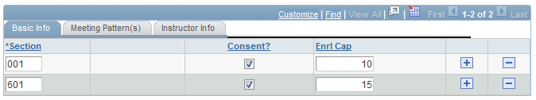

Under the Meeting Pattern(s) tab, you may specify up to two different meeting patterns for each section.
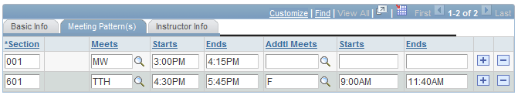

Under Instructor Info, you may specify up to two different instructors for each section.

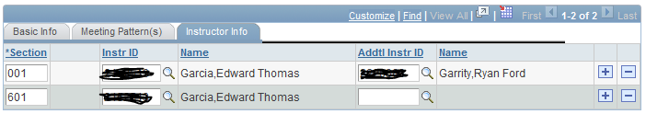

!!PLEASE REMEMBER TO SAVE AFTER YOU ARE DONE MAKING CHANGES!!

Step 5 (optional) – Remove Courses
To remove a course, click the Delete link on the right side. WARNING: Removing a course will delete ALL sections of that course. To remove individual sections, refer to Step 4.

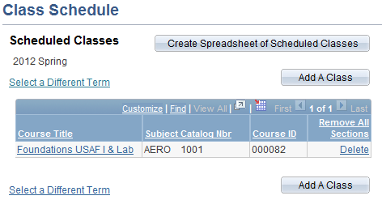

You will be prompted to delete the course and all its sections. Click OK to verify your selection.

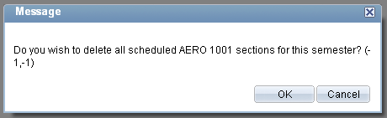

Now this course will no longer be in the list of courses for the selected term.

Conclusion
You have successfully reached the end of PeopleSoft 9 Academic Scheduling Training. If you have further questions, you can email Edward Thomas Garcia, Assistant Registrar of Scheduling at etgarci1@uno.edu.

Thank you!

