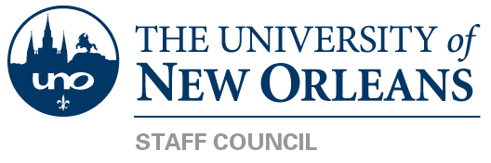

December 15, 2016
UC 208, 10:00AM

- Call to Order

- Executive Committee Reports
  - President, LeeAnne Sip
    - Quorum – minutes approval
    - Staff retention subcommittee update - a lot of ideas from retreat will be incorporated into final report
    - Letter restating our position on diversity as a University will be posted on the Staff Council website.
  - Vice-President, David Lambour
    - Meeting request sent to all subcommittee members
    - Survey for staff needs will go out after holiday break
    - Concerns discussion
  - Treasurer, Tiffany Soublet
    - UNOFCU balance = $1137.63
    - Foundation balance = $5826.56
    - Foundation activity balance = $1273.94
  - Corresponding Secretary, Karen Paisant
  - Recording Secretary, Brian McDonald

- Committee Reports (Call for Members)
  - Staff Concerns Committee
  - Events Committee
  - Awards Committee
  - Membership/Elections Committee

- New Business
  - Budget update will be presented at January meeting.
- Old Business

- Guest Speaker: Office of Enrollment Services – Martin Smith

  - Largest Getting to Know UNO occurred this past November – 850 visitiors
  - Student Portal has been updated
  - Positive response to TOPs
  - Ahead on applications and admits
  - February 11th, scholarship event will be held in conjunction with Explore UNO
- Next Meeting – TBD

- Adjournment

